*Code:*

*# Simple interest calculation*

*principle = int(input("Enter principle value: "))*

*rate = int(input("Enter interest rate: "))*

*time = int(input("Enter time: "))*

*interest = (principle\*rate\*time)/100*

*print(interest)*

*# Compound interest calculation*

*periodElapsed = int(input("Enter number of period elasped: "))*

*interest = principle\*pow((1+(rate/periodElapsed)),periodElapsed\*time)*

*print(interest)*

*print("21CE085 Nirmit Pandya")*

*Output:*

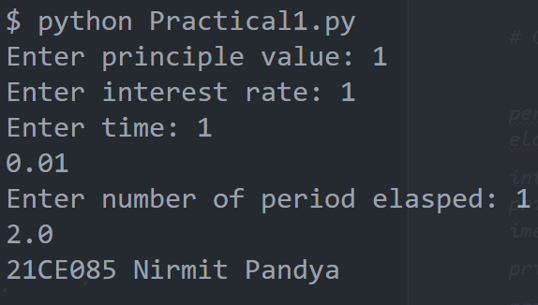

Hello